How Garbage Collection works in Java

- Objects are created on heap in Java. static members are created in method area of Java memory space and local variables memory allocation will be done in stacks area. Heap, stack and method area is shared between different thread.
- Garbage collection is a mechanism provided by Java Virtual Machine to reclaim heap space from objects which are eligible for Garbage collection.
- In some languages, such as C++, dynamically allocated objects must be manually released by use of a delete operator. Java takes a different approach; it handles de-allocation for you automatically.
- Garbage Collection in Java can be carried by a daemon thread called Garbage Collector.
- Before removing an object from memory Garbage collection thread invokes finalize() method of that object and gives an opportunity to perform any sort of cleanup required.
- You as Java programmer cannot force Garbage collection in Java; it will only trigger if JVM thinks it needs a garbage collection based on Java heap size .
- There are methods like System.gc () and Runtime.gc () which is used to send request of Garbage collection to JVM but it’s not guaranteed that garbage collection will happen.
- If there is no memory space for creating new object in Heap Java Virtual Machine throws OutOfMemoryError or java.lang.OutOfMemoryError
heap space .
- Garbage Collection Mechanism in Java
- class Student{
- int a,b;
- public void setData(int c,int d){
- a=c;
- b=d;
- }
- public void showData(){
- System.out.println("Value of a = "+a);
- System.out.println("Value of a = "+b);
- }
- public static void main(String args[]){
- Student s1 = new Student();
- Student s2 = new Student();
- s1.setData(1,2);
- s2.setData(3,4);
- s1.showData();
- s2.showData();
- //Student s3;
- //s3=s2;
- //s3.showData();
- //s2=null;
- //s3.showData();
- //s3=null;
- //s3.showData();
- }
- }
- Step 1:Creating s1,s2 objects :(memory allocated on heap)
- 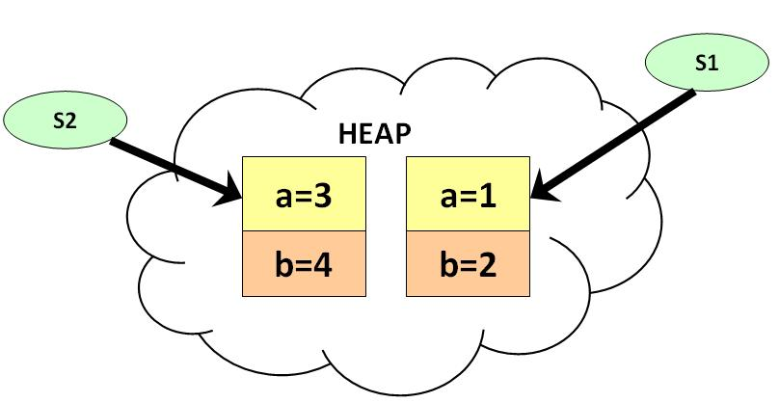
- Step 2:assigning s2 reference to s3, now both can pointing to the same location.

- 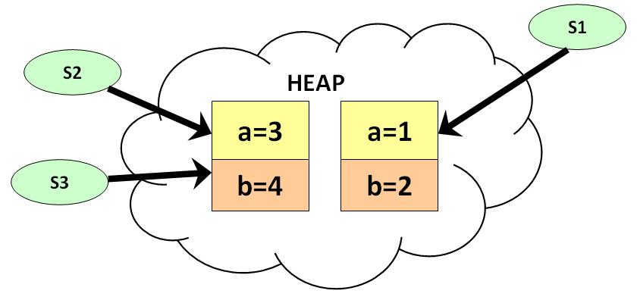
- Step 3: storing NULL into s2(remember only pointer variables can contain null values). Now s2 cannot pointing to its members, only s3 can do.

- 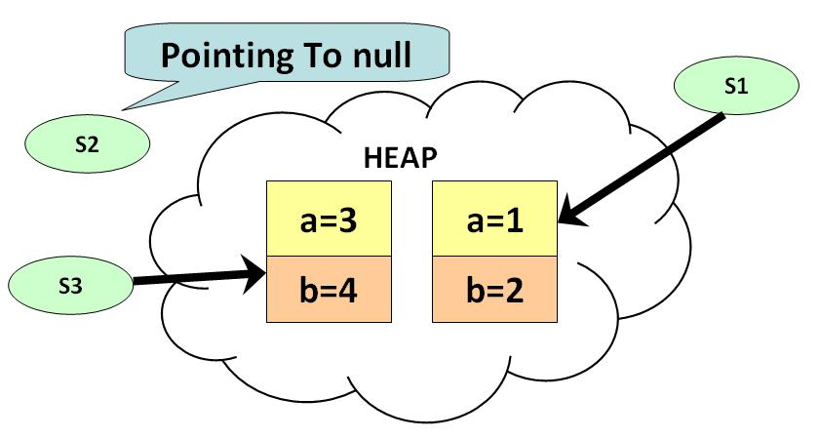

- Step 4: making s3=null, now no pointer pointing to the object members. So this object now eligible for garbage collection.

- 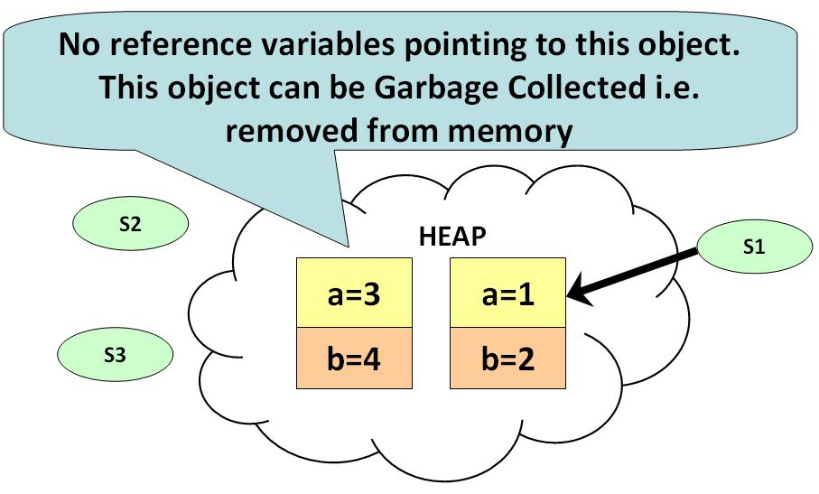
- Garbage Collection Important Points to Note:

- 1) If you want to make your object eligible for Garbage Collection, assign its reference variable to null.
- 2) Primitive types are not objects. They cannot be assigned null.
- 

Is garbage collector a daemon thread?
- Yes GC is a daemon thread.
- Daemon threads are created to provide service to the non-daemon threads in java.
- A daemon thread runs behind the application.
- It is started by JVM.
- The thread stops when all non-daemon threads stop.

Garbage Collector is controlled by whom?
- The JVM controls the Garbage Collector; it decides when to run the Garbage Collector.
- JVM runs the Garbage Collector when it realizes that the memory is running low, but this behavior of JVM cannot be guaranteed.
- One can request the Garbage Collection to happen from within the java program but there is
no guarantee that this request will be taken care of by JVM.

When does an object become eligible for garbage collection?
- An object becomes eligible for Garbage Collection when no live thread can access it.

What are the different ways to make an object eligible for Garbage Collection when it is no longer needed?

- Set all available object references to null once the purpose of creating the object is
served :
public class GarbageCollnTest1
{
public static void main (String [] args)
{
String str = "Set the object ref to null";
//String object referenced by variable str is not eligible for GC yet
str = null;
/*String object referenced by variable str becomes eligible for GC */
}
}

- Make the reference variable to refer to another object : Decouple the reference variable from the object and set it refer to another object, so the object which it was referring to before reassigning is eligible for Garbage Collection.

publc class GarbageCollnTest2
{
public static void main(String [] args)
{
String str1 = "Garbage collected after use";
String str2 = "Another String";
System.out.println(str1);
//String object referred by str1 is not eligible for GC yet
str1 = str2;
/* Now the str1 variable referes to the String object "Another String" and the object "Garbage collected after use" is not referred by any variable and hence is eligible for GC */
}
}

- Creating Islands of Isolation: If you have two instance reference variables which are referring to the instances of the same class, and these two reference variables refer to each other and the objects referred by these reference variables do not have any other valid reference then these two objects are said to form an Island of Isolation and are eligible for Garbage Collection.
public class GCTest3
{
GCTest3 g;
public static void main(String [] str)
{
GCTest3 gc1 = new GCTest3();
GCTest3 gc2 = new GCTest3();
gc1.g = gc2; //gc1 refers to gc2
gc2.g = gc1; //gc2 refers to gc1
gc1 = null;
gc2 = null;
//gc1 and gc2 refer to each other and have no other valid //references
//gc1 and gc2 form Island of Isolation
//gc1 and gc2 are eligible for Garbage collection here
}
}

Can the Garbage Collection be forced by any means?
- No. The Garbage Collection cannot be forced, though there are few ways by which it can be requested there is no guarantee that these requests will be taken care of by JVM.

How can the Garbage Collection be requested?

There are two ways in which we can request the jvm to execute the Garbage Collection.
- The methods to perform the garbage collections are present in the Runtime class provided by java. The Runtime class is a Singleton for each java main program.
The method getRuntime() returns a singleton instance of the Runtime class. The method gc() can be invoked using this instance of Runtime to request the garbage collection.

- Call the System class System.gc() method which will request the jvm to perform GC.
System.gc()
Runtime.getRuntime().gc().

What is the purpose of overriding finalize() method?
- The finalize() method should be overridden for an object to include the clean up
code or to dispose of the system resources that should to be done before the object is garbage collected.

The finalize( ) Method
- Sometimes an object will need to perform some action when it is destroyed.
- For example, if an object is holding some non-Java resource such as a file handle, database connections, and network connections then you might want to make sure these resources are freed before an object is destroyed.
- To handle such situations, Java provides a mechanism called finalization.

protected void finalize( )
{
// finalization code here
}

- By using finalization, you can define specific actions that will occur when an object is just about to be reclaimed by the garbage collector.
- To add a finalizer to a class, you simply define the finalize( ) method.
- The Java run time calls that method whenever it is about to recycle an object of that class.
- Inside the finalize( ) method you will specify those actions that must be performed before an object is destroyed.

class OpenAFile
{
FileInputStream aFile = null;
OpenAFile(String filename)
{
try
{
aFile = new FileInputStream(filename);
} catch (java.io.FileNotFoundException e) {
System.err.println("Could not open file " + filename);
}
}}

As a part of good programming practice, the open file should be closed :

//Overriding finalize() method of java.lang.Object class
protected void finalize () throws Throwable {
if (aFile != null) {
aFile.close();
aFile = null;
}
}

- The garbage collector runs periodically, checking for objects that are no longer referenced by any running state or indirectly through other referenced objects.
- Right before an asset is freed, the Java run time calls the finalize() method on the object. The finalize( ) method has this general form:
- The finalize() method is defined in the java.lang.Object class and its modifier is defined as protected. The finalize() method is not public because it should only be invoked by JVM and not by anyone else and protected so that it can be overridden by the subclasses.
- It is important to understand that finalize( ) is only called just prior to garbage collection.
- It is not called when an object goes out-of-scope, for example. This means that you cannot know when—or even if—finalize( ) will be executed.
- Therefore, your program should provide other means of releasing system resources, etc., used by the object.
- It must not rely on finalize( ) for normal program operation.

Note: If you are familiar with C++, then you know that C++ allows you to define a destructor for a class, which is called when an object goes out-of-scope. Java does not support this idea or provide for destructors. The finalize( ) method only approximates the function of a destructor. As you get more experienced with Java, you will see that the need for destructor functions is minimal because of Java's garbage collection subsystem.

If an object becomes eligible for Garbage Collection and its finalize() method has been called and inside this method the object becomes accessible by a live thread of execution and is not garbage collected. Later at some point the same object becomes eligible for Garbage collection, will the finalize() method be called again?
- No, but we can forcefully call more than one time.

How many times does the garbage collector calls the finalize() method for an object?
- Only once.

Program for the above two questions:
public class abc
{
public static void main ( String args [ ] )
{
abc a = new abc();
a.finalize();
a.finalize();
a = null;
System.gc();
//System.gc();
}

protected void finalize()
{
System.out.println("I am in finalize...");
}
}

public class Main
{
private static int id;
private int myId;
Main()
{
myId = id++;
System.out.println("Created #" + myId);
}
protected void finalize() throws Throwable
{
System.out.println("Finalized #" + myId);
super.finalize();
}
public static void main(String[] args)
{
Main fd;
for (int i = 0; i < 10000; i++)
fd = new Main();
}
}
class Book {
boolean checkedOut = false;
Book(boolean checkOut)
{
checkedOut = checkOut;
}
void checkIn()
{
checkedOut = false;
}
public void finalize()
{
if (checkedOut)
System.out.println("Error: checked out");
}
}

public class TerminationCondition {
public static void main(String[] args)
{
Book novel = new Book(true);
// Proper cleanup:
novel.checkIn();
// Drop the reference, forget to clean up:
new Book(true);
// Force garbage collection & finalization:
System.gc();
}
}

So, the following code is wrong:
Runtime rt = new Runtime();
rt.gc();
The following code is correct:
Runtime rt = Runtime.getRuntime();
rt.gc();

class RuntimeGC
{
static Runtime r1;

protected void finalize()
{
System.out.println("finalization of object");
}
public static void main(String[] args)
{
new RuntimeGC();
r1=Runtime.getRuntime();
r1.gc();

}
}

Note: exec(String command): This method is used to execute the command.
Here command is a specified system command. It can also be used to execute
any .exe file.

import java.io.IOException;
public class RuntimeExec
{
public static void main(String[] args)
{
try
{
Process process = Runtime.getRuntime().exec("notepad.exe");
}catch (IOException e)
{
e.printStackTrace();
}
}
}

How to get max memory, free memory and total memory in Java
Getting free memory, total memory and max memory on JVM is using by
Runtime class in Java.

To get free Memory in Java :
Runtime.getRuntime().freeMemory() method, this will return size
in bytes, which you convert in Mega Bytes for better readability.
To get total Memory in Java:
Runtime.getRuntime().totalMemory()
To get maximum Heap Size from Java Program:
Runtime.getRuntime().maxMemory()

class MemoryUtil
{
private static final int MB = 1048576;
public static void main(String args[])
{
long freeMemory = Runtime.getRuntime().freeMemory();
long totalMemory = Runtime.getRuntime().totalMemory();
long maxMemory = Runtime.getRuntime().maxMemory();

System.out.println("JVM freeMemory: " + (freeMemory/MB));
System.out.println("JVM totalMemory : "+ (totalMemory/MB));
System.out.println("JVM maxMemory : "+ (maxMemory/MB));

}
}

Playing with JVM / Java Heap Size:
- Java programs executes in JVM uses Heap of memory to manage the data.
- If your Java program requires a large amount of memory, it is possible that the virtual machine will begin to throw OutOfMemoryError instances when attempting to instantiate an object.
- The default heap size if 1 MB and can increase as much as 16 MB.

Setting/Increase JVM heap size
It is possible to increase heap size allocated by the Java Virtual Machine (JVM) by using command line options.

Following are few options available to change Heap Size.
-Xms<size> set initial Java heap size
-Xmx<size> set maximum Java heap size

Getting / Reading default heap size
It is possible to read the default JVM heap size programmatically by using totalMemory() method of Runtime class. Use following code to read JVM heap size.

class Example
{
private static final int MB = 1048576;
public static void main(String args[])
{
String str1 = "Garbage collected after use";
String str2 = "Another String";
System.out.println(str1);
str1 = str2;
long freeMemory = Runtime.getRuntime().freeMemory();
long totalMemory = Runtime.getRuntime().totalMemory();
long maxMemory = Runtime.getRuntime().maxMemory();

System.out.println("JVM freeMemory: " + (freeMemory/MB));
System.out.println("JVM totalMemory : "+ (totalMemory/MB));
System.out.println("JVM maxMemory : "+ (maxMemory/MB));

}
}

For example, you can set minimum heap to 64 MB and maximum heap 256 MB for the above Java program Example.
java -Xms64m -Xmx256m MemoryUtil

